P1

0,7

0,0

P2

P1= p2;

P1

0,0

P2

0,7

P2

p2.x=5;

5,8

p2.y=8;

0,0

p1

5,8

p2

**package** jmlasdfj;

**public** **class** pu {

**public** **static** **void** main(String[] args) {

// **TODO** Auto-generated method stub

Point p1 = **new** Point();

Point p2 = **new** Point(0,7);

p1=p2;

System.***out***.println(p1.x+" "+p1.y);

System.***out***.println(p2.x+" "+p2.y);

p2.x=5;

p2.y=8;

System.***out***.println(p1.x+" "+p1.y);

System.***out***.println(p2.x+" "+p2.y);

}

}

**public** **class** Point {

**int** x;

**int** y;

**public** Point(){

x=0;

y=0;

}

**public** Point(**int** a, **int** b){

x= a;

y= b;

}

}

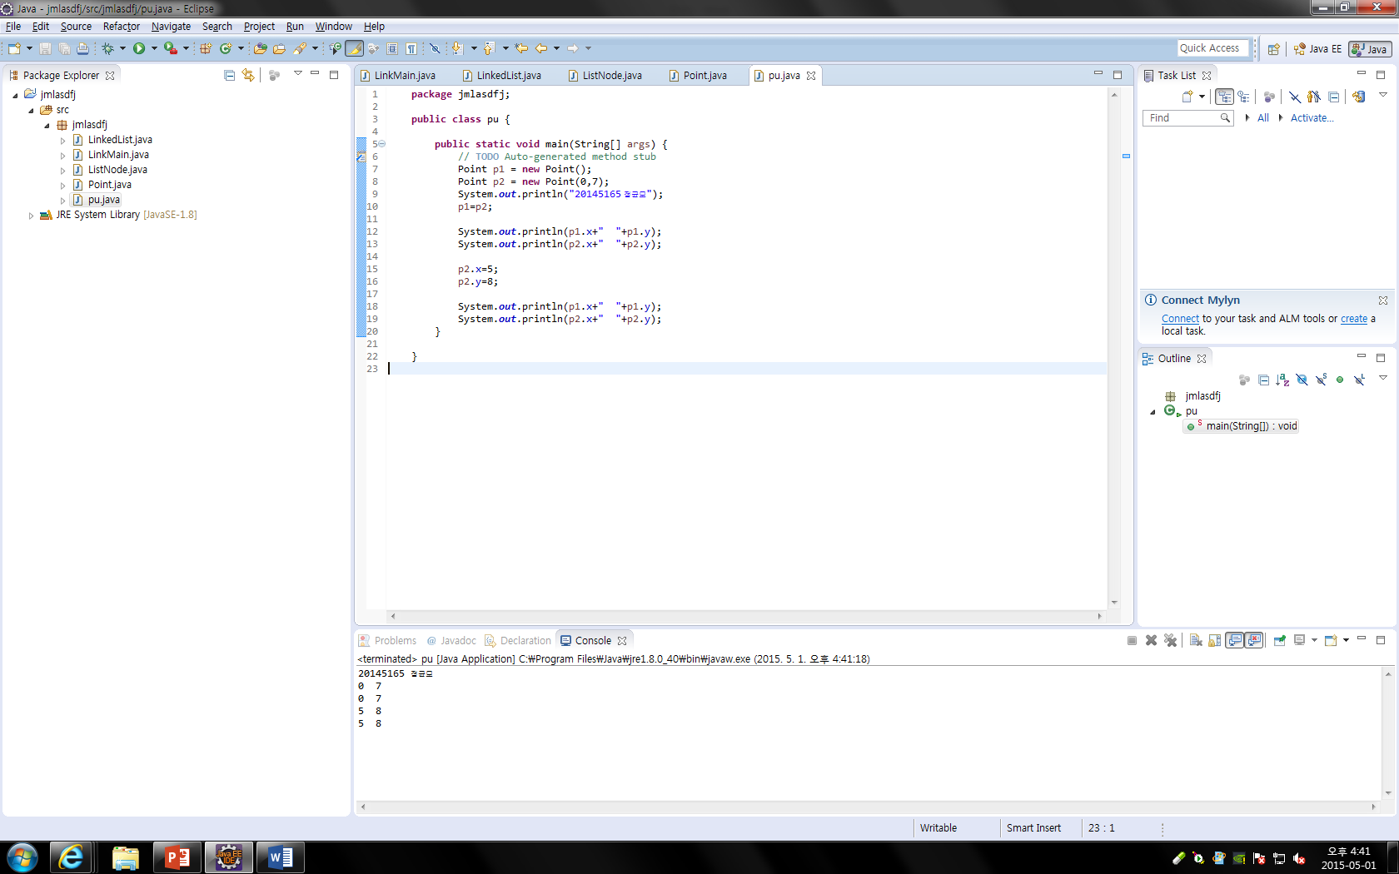

**public** **class** LinkMain {

**public** **static** **void** main(String[] args) {

LinkedList ll = **new** LinkedList();

LinkedList l2 = **new** LinkedList();

ll.addFirstNode("정균모");

l2.addFirstNode("균모");

ll.printList();

l2.printList();

}

}

**public** **class** LinkedList {

ListNode head;

**public** **void** addFirstNode(String x) {

ListNode Ln = **new** ListNode();

Ln.data=x;

Ln.link=head;

head = Ln;

}

**public** **void** insertNode(ListNode p, String x){

ListNode Ln = **new** ListNode();

Ln.data=x;

**if**(head == **null**){

head = Ln;

head.link = **null**;

}**else** **if**(p == **null**){

Ln.link =head;

head = Ln;

}**else**{

}

}

**public** **void** printList(){

ListNode p;

System.***out***.print("(");

p = head;

**while**(p != **null**){

System.***out***.print(p.data);

p=p.link;

**if**(p != **null**){

System.***out***.print(",");

}

}

System.***out***.println(")");

}

}

**public** **class** ListNode {

String data;

ListNode link;

}

